Home Appliance AI Support Assistant
A Retrieval-Augmented Chatbot for Whirlpool and GE Appliance Support

Medhasri Kolluru,
Sanjana Ghanta,
Manisha Eerlapally,
and Divya Kotha
Ethics in Artificial Intelligence (MSAI-633-M50)
Ying Lin
July 24, 2026

Appliance Support Assistant: Project Proposal

This is a retrieval augmented chatbot for troubleshooting washing machines, refrigerators, and dishwashers, using only public support pages from Whirlpool and GE Appliances. Every answer cites its source page, and the bot refuses when it lacks enough context.
Proposed Hypothesis

This project tests the hypothesis that a retrieval-augmented chatbot grounded in official Whirlpool and GE Appliances documentation, using hybrid retrieval and cross-encoder reranking, produces troubleshooting answers that are more accurate and more verifiable through citations than an ungrounded language model answering the same questions, while still carrying a residual risk of unfaithful or misapplied citations that keeps human review necessary. The supporting sources below justify the accuracy claim; the opposing sources justify the residual-risk claim. The evaluation plan tests both by comparing baseline B0 against baseline B3 on answer correctness and citation validity.
Team and Roles
Name | Role | Owns
Medhasri Kolluru | Data Engineer | Scraper (both sites), robots.txt/rate limit compliance, HTML+PDF extraction, chunking build.
Sanjana Ghanta | RetrievalEngineer | Embeddings, ChromaDB, BM25/dense/hybrid retrieval, reranker, generation prompt, citations.
Manisha Eerlapally | Frontend Engineer | Chat UI, history, citation display, retrieval trace panel, refusal/referral UI.
Divya Kotha | Project Manager | Golden set, baselines/metrics, task board, PR review, ethics report, schedule.

Domain, Corpus, and Technology Stack
- Domain: consumer appliance troubleshooting. Sources: public Whirlpool.com and GEAppliances.com support pages, no login needed.
- Categories: washing machines, refrigerators, dishwashers only.
- Corpus target: 80 to 100 HTML pages, 5 to 8 PDF manuals, 3+ pages with error code or spec tables, 500 to 1000 chunks, split across both brands and all three categories.
- Stack: Python; Trafilatura/BeautifulSoup for HTML; PyMuPDF/pdfplumber for PDFs; embedding model BAAI/bge-small-en-v1.5; ChromaDB vector store; dense, BM25, and hybrid retrieval; reranker cross-encoder/ms-marco-MiniLM-L6-v2; generation model GPT-4o-mini; Streamlit UI.

System Architecture
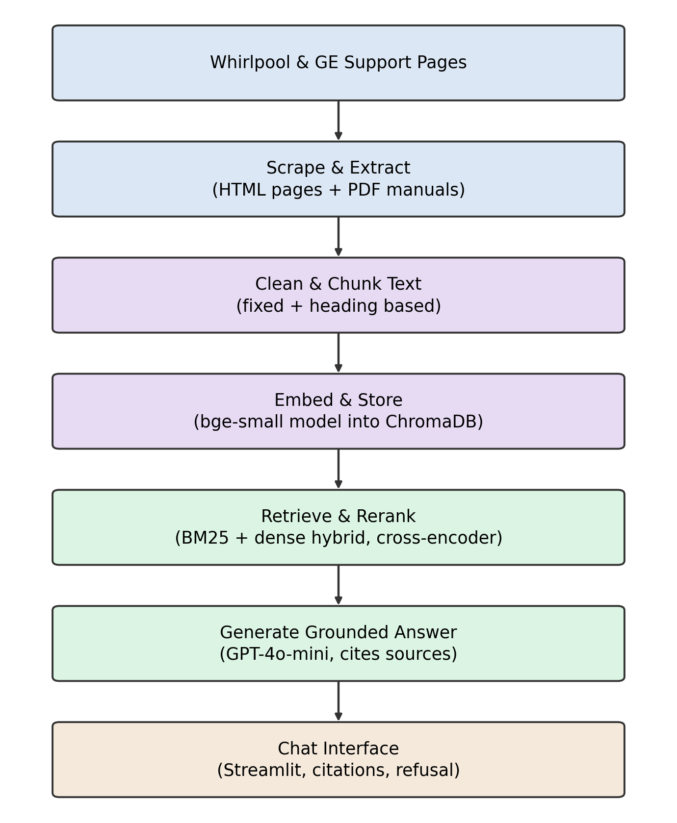
Figure 1. Seven stage pipeline from public source pages to a cited chat answer.

Chunking, Grounding, and Data Flow
- Two strategies: fixed chunking (400 tokens, 60 token overlap) and structure aware chunking (split by heading, heading kept as metadata).
- Chunk IDs are deterministic (hash of URL + heading + index), so re-chunking reuses saved page text without re-crawling; old chunk IDs are deleted before new ones are inserted, then checked for orphans.
- Answers are grounded only in retrieved passages, with a citation (URL + metadata) on every factual claim, and a plain refusal when context is insufficient.
- Electrical, gas, recall, and warranty questions trigger a safety referral instead of a generated answer.
- Query flow: user question to embedding + BM25 in parallel, merged hybrid results reranked by the cross encoder, top passages sent to GPT-4o-mini with a grounding prompt, and the cited answer (or refusal) returned to the Streamlit chat.

Evaluation Plan
Category | Count | Category | Count
Single-hop | 15 | Unanswerable | 8
Multi-hop | 6 | Ambiguous/adversarial | 3
Comparative | 4 | Total | 40
Temporal | 4
- 60/40 dev-test split; every question and answer human verified by a second team member before the set is locked.
- Baselines: B0 LLM only, B1 BM25 only, B2 dense only, B3 hybrid + reranker.
- Metrics: Recall@5, Recall@20, MRR, nDCG@10, answer correctness, citation validity, refusal accuracy, latency.
Ethics, Risks, and Business Case
- Ethics: robots.txt compliance, 1 request/sec rate limit, descriptive User-Agent, no PII collected, prompt injection tests in the eval set, scrape timestamps to flag stale content.
- Risks and mitigations: rate limiting (cache pages, hold the 1 req/sec cap); thin PDF tables (pdfplumber plus manual spot check); small golden set noise (second reviewer sign off before locking).
- Business case: many service calls cover issues already documented publicly; a cited, grounded assistant is a faster self-serve front door, and its unanswered-question log shows the support team which docs to write next.
GitHub Repository
Repository (branch protection on main, issues board, .gitignore, no committed keys): https://github.com/Shri391-dcm/HomeBoot
Supporting Research Sources

The following five sources support the claim that retrieval grounding, hybrid search, and reranking improve chatbot accuracy and verifiability.
Lewis et al. (2020) introduced retrieval-augmented generation, showing that pairing a language model with retrieval over an external knowledge source improves performance on knowledge-intensive tasks. This is the core mechanism this project depends on: retrieving the manufacturer passage before answering, rather than trusting the model's memory.
Shuster et al. (2021) found, through human evaluation, that retrieval augmentation substantially reduced hallucination in conversational chatbots while preserving conversational quality, directly supporting a multi-turn support assistant like this one.
Karpukhin et al. (2020) showed dense passage retrieval outperformed BM25 keyword search by nine to nineteen absolute points in top-20 accuracy, justifying this project's hybrid retriever, since dense embeddings catch paraphrased troubleshooting questions keyword search alone would miss.
Nogueira and Cho (2019) showed a BERT cross-encoder reranker improved mean reciprocal rank by twenty-seven percent on the MS MARCO benchmark, the basis for this project's reranking stage after hybrid retrieval.
Kim, Sachdeva, and Dennis (2025), in the International Journal of Information Management, found higher user satisfaction with chatbot-based IT self-service than search-tool self-service, empirical support for the business case that a chatbot can outperform static documentation here.
Opposing Research Sources

The following two sources support the residual-risk half of the hypothesis, the reason this design still includes refusal and safety-referral rules.
Wallat, Heuss, de Rijke, and Anand (2024) found that a majority of citations in a RAG-optimized model showed unfaithful post-rationalization, meaning a citation next to an answer does not prove the retrieved passage actually drove it, which is why citation validity is measured as its own metric here.
Brand (2024), in the peer-reviewed journal AI & Society, analyzed the 2024 Air Canada tribunal ruling holding the airline liable for its chatbot's bad advice, the direct legal basis for this project's mandatory safety referral on electrical, gas, recall, and warranty questions.

References

Brand, J. L. M. (2024). Air Canada's chatbot illustrates persistent agency and responsibility gap problems for AI. AI & Society. https://doi.org/10.1007/s00146-024-02096-7
Karpukhin, V., Oǧuz, B., Min, S., Lewis, P., Wu, L., Edunov, S., Chen, D., & Yih, W. (2020). Dense passage retrieval for open-domain question answering. In Proceedings of the 2020 Conference on Empirical Methods in Natural Language Processing (pp. 6769–6781). Association for Computational Linguistics. https://doi.org/10.18653/v1/2020.emnlp-main.550
Kim, A., Sachdeva, A., & Dennis, A. R. (2025). From self-service to AI-assisted service: A mixed-method study of IT support service provision using search tools and chatbots. International Journal of Information Management, 84, Article 102938. https://doi.org/10.1016/j.ijinfomgt.2025.102938
Lewis, P., Perez, E., Piktus, A., Petroni, F., Karpukhin, V., Goyal, N., Küttler, H., Lewis, M., Yih, W., Rocktäschel, T., Riedel, S., & Kiela, D. (2020). Retrieval-augmented generation for knowledge-intensive NLP tasks. Advances in Neural Information Processing Systems, 33, 9459–9474.
Nogueira, R., & Cho, K. (2019). Passage re-ranking with BERT. arXiv. https://arxiv.org/abs/1901.04085
Shuster, K., Poff, S., Chen, M., Kiela, D., & Weston, J. (2021). Retrieval augmentation reduces hallucination in conversation. In Findings of the Association for Computational Linguistics: EMNLP 2021 (pp. 3784–3803). Association for Computational Linguistics. https://doi.org/10.18653/v1/2021.findings-emnlp.320
Wallat, J., Heuss, M., de Rijke, M., & Anand, A. (2024). Correctness is not faithfulness in RAG attributions. arXiv. https://arxiv.org/abs/2412.18004

